**BCVD1007 – Full Stack Development II – Lab 4**

* Windows & DOM Selection

**Developer Note:**

* Use the web documents and window web api
* Start code for this lab can found here:
  + <https://tinyurl.com/y49wsa2j>

References:

<https://developer.mozilla.org/en-US/docs/Web/API/Document>

<https://developer.mozilla.org/en-US/docs/Web/API/Window>

**Exercise 1:**

Create a html document named **Ex1.html** and a function named **windowDetails** that has the following requirements:

* Invoked within the page
* Outputs to the console the following window properties
  + Inner width and height
  + Outer width and height
  + The window is in full screen mode or not
  + The window location the file
  + The visibility of the status bar, scroll bars and menu bar.
  + The window history object

The expected output should be as follows:  
  
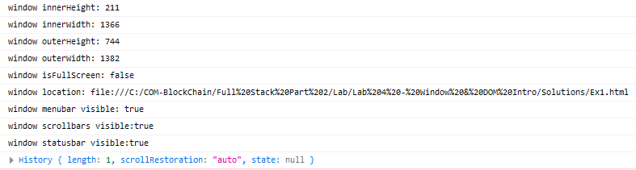

**Exercise 2:**

Use the starter code for **Ex2.html** and code the following:

* Create a function **openTabs()** that will:
  + have no parameters
  + will iterate over the the siteUrl array and open each url in it’s own window
* Invoke the openTabs function

**Exercise 3:**

Use the starter code for **Ex3.html** and code the following:

* Create three functions
  + **displayAlert()** will display an alert popup
  + **displayPrompt()** will display a prompt popup
  + **displayConfirm()** will display a confirm popup and close the window, if Yes is returned by user, otherwise No will do nothing
* Modify the three buttons in the HTML document to invoke the functions when the button is clicked by the user.  
    
  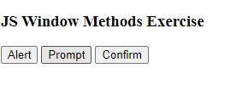  
    
  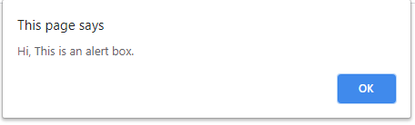  
  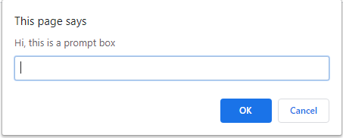  
  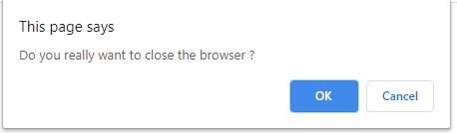

**Exercise 4:**

Use the starter code for **Ex4.html** and code the following:

* Create a function **getDOMElements()** that does the following:
  + Uses the **document.getElement** methods to find and output the following elements
    - The element with the **menu ID**
    - All the elements with the class name **item**
    - The element with the class name **highlight**
    - The element with name **readBtn**
    - The **h1** elements
    - The **h2** element
* Invoke the function **getDOMElements()**

The expected output is as follows:

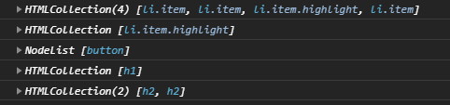

**Exercise 5:**

Use the starter code for **Ex5.html** and code the following:

* Implement the same requirements as in Exercise 4, but this time use the document query selector methods

<https://developer.mozilla.org/en-US/docs/Web/API/Document/querySelector>

<https://developer.mozilla.org/en-US/docs/Web/API/Element/querySelectorAll>

The output will be as follows:

